Experiment name: Downloading and Installing Cisco Packet Tracer
- Objectives:
The main goals of this experiment were to:
- Visit the official Cisco Networking Academy website.
- Download the Cisco Packet Tracer software successfully.
- Install and set up Packet Tracer on the computer
- Tools Required:
- Computer: A laptop or desktop that supports Windows, macOS, or Linux.
- Internet Connection: A stable internet connection is needed to visit the official website and download the software.
- Cisco NetAcad Account: A valid account (created through an instructor or the Skills for All platform) is required to log in and access the download.
- Simulation:
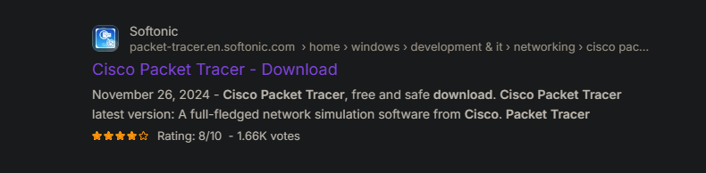
Step 1: Go to the Link.
Figure 1.1: Search for cisco packet tracer in browser

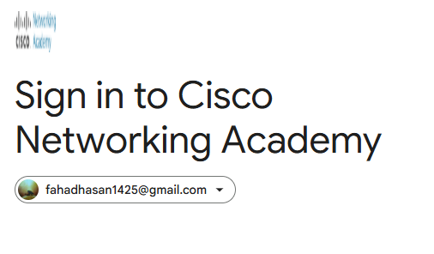
Step 2: Sign in to Cisco Networking Academy.
Figure 1.2: Sign in to Cisco NetAcad
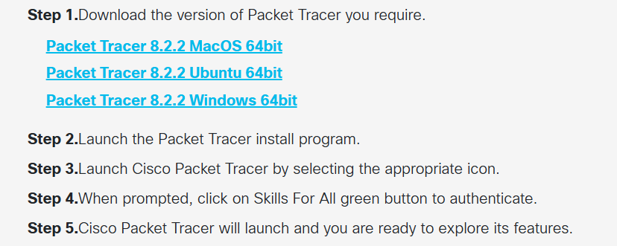
Step 3: Downloading windows version packet tracer.
Figure 1.3: Downloading windows version

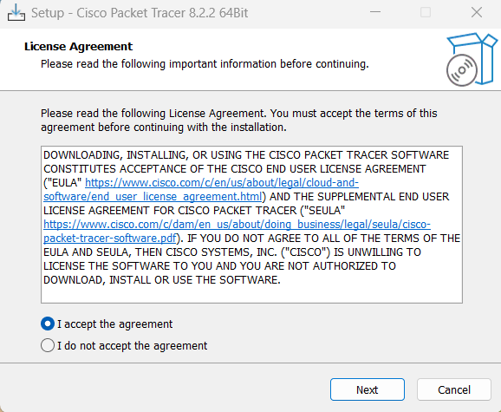
Step 4: Set up for license agreement.
Figure 1.4: Search for cisco packet tracer in browser.

Step 5: Final Installation Process.
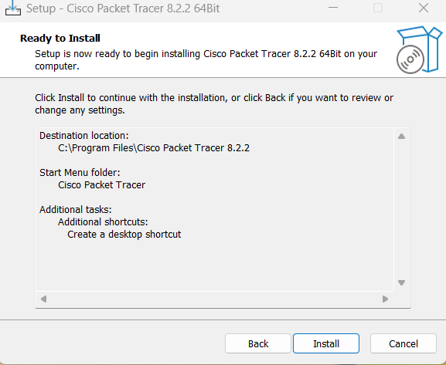

Figure 1.5: Final Installation

Step 6: Sign in Cisco Packet Tracer for using the app.
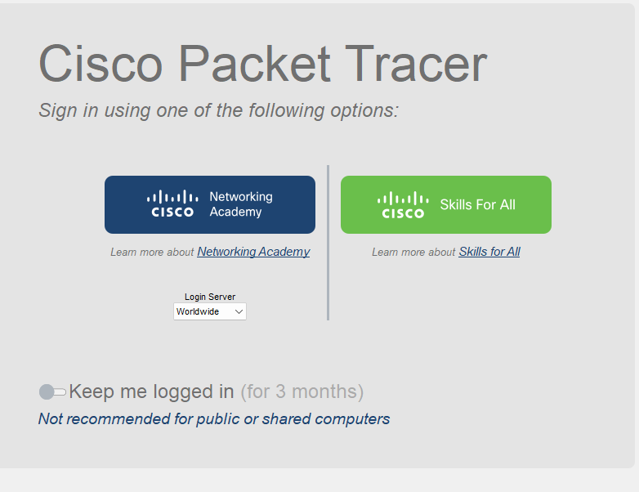

Figure 1.6: Sign in Cisco Packet Tracer.

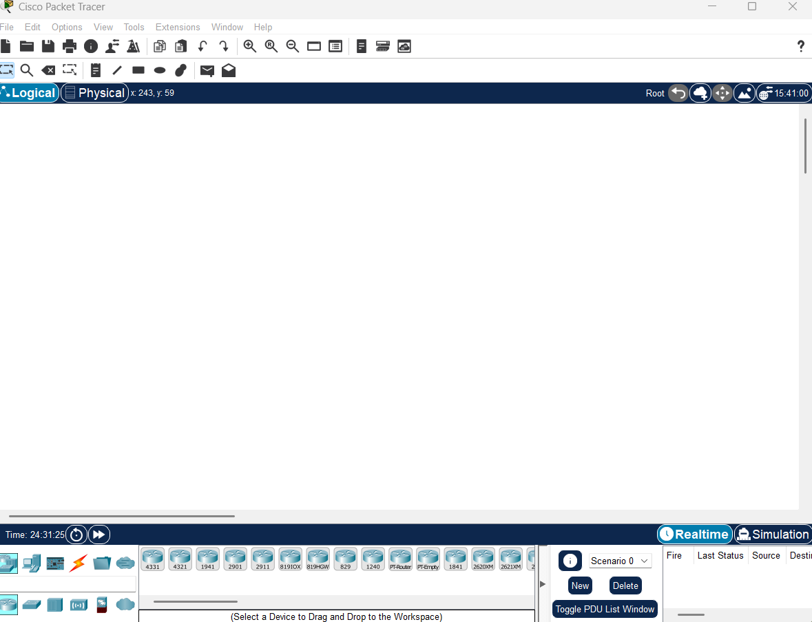
Step 7: Opening Installed App.
Figure 1.7: Sign in Cisco Packet Tracer.

- Description:
Cisco Packet Tracer is a versatile network simulation program created by Cisco Systems. It helps users design and test different network setups, simulate real-life networking scenarios, and observe how data packets move across a network in real time.

- Discussion and Conclusion:
The experiment of downloading and installing Cisco Packet Tracer was completed successfully. The goals were achieved — I downloaded it from the official Cisco website, installed it properly, and made sure it was running fine. This task helped me understand the importance of following each step correctly and having the required things like a NetAcad account before starting the installation. Now that the software is set up, I’ll be able to use Packet Tracer for upcoming experiments. It will help me practice networking concepts, build virtual networks, and learn how to configure and troubleshoot them in a practical way.

